CO2-ASSESSMENT TOOL-DEBUGGING QUESTIONS
NAME: M.Balaji
REG NO:192525059
COURSE NAME : DATA STRUCTURES
COURSE CODE : CSA0307

QUESTION 1:

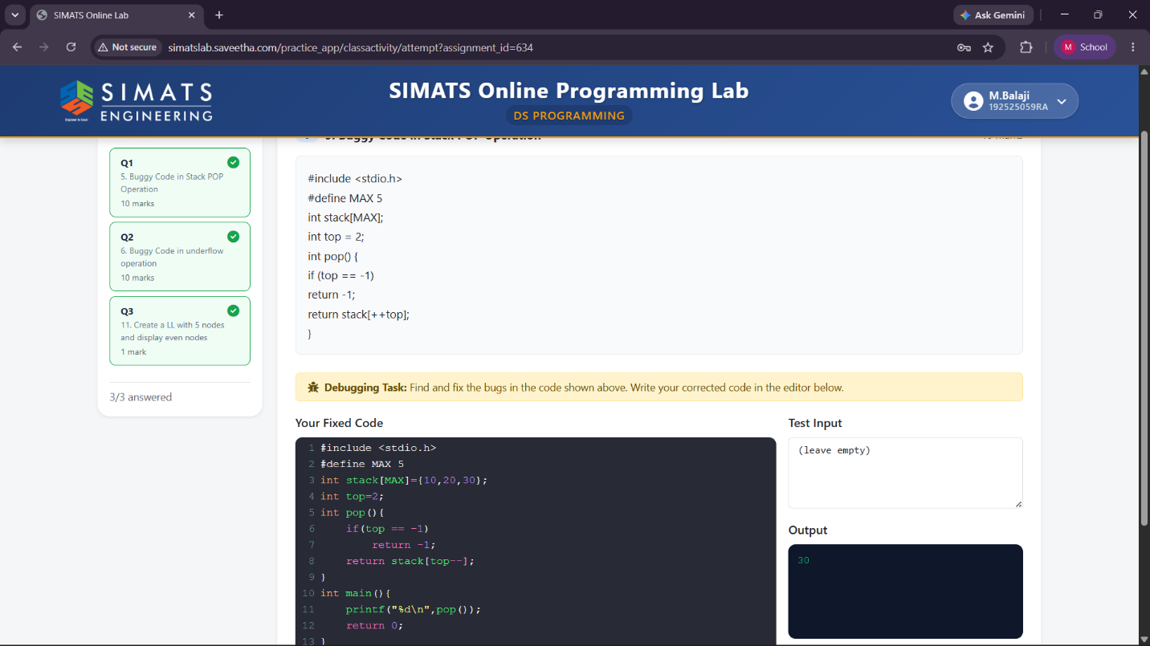

QUESTION 2:
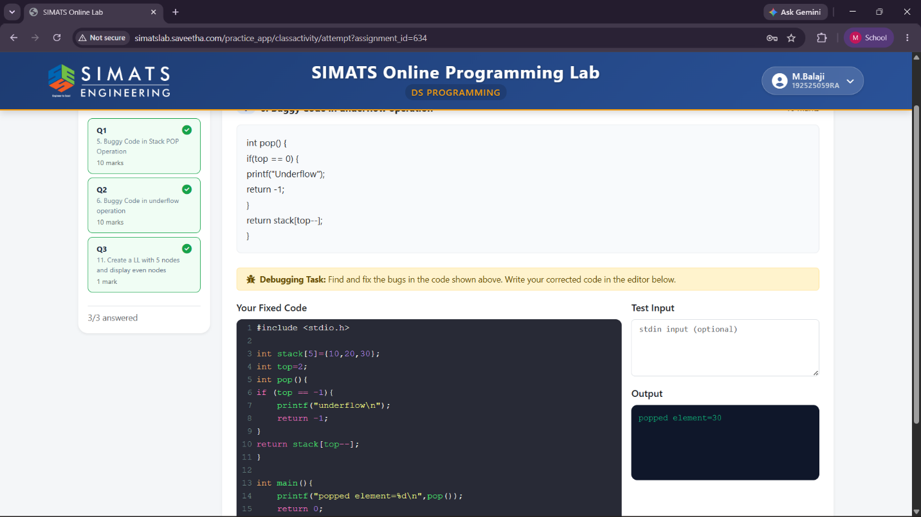

QUESTION 3:
